AgriIntelligence – An End-to-End Crop, Weather & Market Analytics Platform

A Project Report Submitted in the partial fulfillment of the requirements for the award of the degree of

BACHELOR OF TECHNOLOGY
In

DEPARTMENT OF COMPUTER SCIENCE ENGINEERING
By
D Kamal | : 2420030290
V Chandra | : 2420030291
G Khethana | : 2420030461

Under the Esteemed Guidance of

B Prathusha

Assistant Professor

Department of CSE

AY- 2026–2027

Semester: Odd semester




K L (Deemed to be) University
DEPARTMENT OF COMPUTER SCIENCE AND ENGINEERING

Declaration

The Project Report entitled “AgriIntelligence – An End-to-End Crop, Weather & Market Analytics Platform ” is a record of Bonafide work of D Kamal – 2420030290, V Chandra – 2420030291, G Khethana – 2420030461 submitted in partial fulfillment for the award of B. Tech in Computer Science and Engineering to the K L University. The results embodied in this report have not been copied from any other departments/University/Institute.

D Kamal – 2420030290
V Chandra – 2420030291
G Khethana – 2420030461
K L (Deemed to be) University
DEPARTMENT OF COMPUTER SCIENCE AND ENGINEERING

CERTIFICATE

This is certify that the mini project based report entitled “AgriIntelligence – An End-to-End Crop, Weather & Market Analytics Platform” is a bonafide work done and submitted by D Kamal – 2420030290, V Chandra – 2420030291, G Khethana – 2420030461 in partial fulfillment of the requirements for the award of the degree of BACHELOR OF TECHNOLOGY in Department of Computer Science and Engineering, K L (Deemed to be University), during the academic year 2026-2027.

Signature of the Guide

Signature of the Course Coordinator Signature of the HOD

ACKNOWLEDGEMENT
The success in this project would not have been possible but for the timely help and guidance rendered by many people. Our wish to express my sincere thanks to all those who has assisted us in one way or the other for the completion of my project.

Our greatest appreciation to my Course Coordinator Nalajala Sunanda, and my guide
B Prathusha, Department of Computer Science and Engineering which cannot be expressed in words for his/her tremendous support, encouragement and guidance for this project.

We express our gratitude to Dr. P.Venkateshwar Sir (CSE), Head of the Department for Computer Science Engineering for providing us with adequate facilities, ways and means by which we are able to complete this project-based Lab.

We thank all the members of teaching and non-teaching staff members, and also who have assisted me directly or indirectly for successful completion of this project. Finally, I sincerely thank my parents, friends and classmates for their kind help and cooperation during my work.

D Kamal – 2420030290
V Chandra – 2420030291
G Khethana – 2420030461
Abstract

Agriculture plays a vital role in the economy, and data-driven decision-making can help improve agricultural productivity and market awareness. The project “AgriIntelligence – An End-to-End Crop, Weather & Market Analytics Platform” is designed to analyze agricultural data, explore the relationship between weather conditions and crop yield, and provide insights into agricultural market prices through an interactive dashboard.

The platform uses Python and libraries such as Pandas, NumPy, Matplotlib, Seaborn, and Scikit-learn for data processing, analysis, visualization, and machine learning. It integrates crop yield data, weather-related attributes such as rainfall and temperature, pesticide usage information, and agricultural market price data. A Random Forest Regression model is developed to predict crop yield based on factors including country, crop type, year, rainfall, pesticide usage, and temperature. The model is evaluated using Mean Absolute Error (MAE), Mean Squared Error (MSE), Root Mean Squared Error (RMSE), and the R² score.

The platform is implemented using Streamlit and provides interactive modules for Crop Analytics, Weather Analytics, Agricultural Factors, Market Analytics, and Crop Yield Prediction. Users can explore crop performance, examine weather patterns, analyze agricultural factors, compare commodity prices, and obtain estimated crop yields by entering relevant input values.

The main objective of AgriIntelligence is to transform agricultural datasets into meaningful visual insights and predictive information that can support better agricultural planning and decision-making. By combining data analytics, visualization, and machine learning in a single platform, the project demonstrates how technology can assist in understanding crop productivity and agricultural market trends.

Index
S. No. | Chapters | Topics | Page.no
 |  | Acknowledgement
 |  | Abstract
1 | Introduction | 1.1 Background of the project  1.2 Problem statement  1.3 Scope of the project  1.4 Objective(s)  1.5 Importance of the application  1.6 Target users/audience | 1-10
2 | System Requirements | 2.1 Hardware requirements  2.2 Software requirements  2.3 Development tools and frameworks | 11-20
3 | Technology Stack | 3.1 Front-end (e.g., React.js, Angular, HTML/CSS)  3.2 Back-end (e.g., Node.js, Django, Spring Boot)  3.3 Database (e.g., MongoDB, MySQL, PostgreSQL)  3.4 Version Control (e.g., Git, GitHub)  3.5 APIs or External services (e.g., Firebase, Stripe) | 21-30
4 | System Architecture | 4.1 High-level architecture diagram  4.2 Description of each layer (frontend, backend, database)  4.3 Deployment architecture (e.g., cloud, local, CI/CD pipelines) | 31-35
5 | Design | 5.1 Wireframes or mockups  5.2 ER Diagram / Database schema | 36-42
6 | Implementation | 6.1 Module-wise implementation  6.2 Front-end logic (UI rendering, state management)  6.3 Backend logic (routes, controllers, business logic)  6.4 Database connectivity  6.5 API integration  6.6 Authentication & Authorization | 43-55
7 | Features | 7.1 List of main features  7.2 How each feature works (user perspective + technical description) | 56-60
8 | Testing | 8.1 Postman testing (frontend/backend)  8.2 Integration testing  8.3 Tools used for testing  8.4 Test cases and results | 61-67
9 | Deployment | 9.1 Steps to deploy  9.2 Environment configuration  9.3 Hosting of frontend and backend | 68-73
10 | Challenges & Limitations | 10.1 Issues faced during development  10.2 Solutions applied  10.3 Current limitations or known bugs | 74-80
11 | Future Enhancements | 11.1 Planned features  11.2 Possible integrations or optimizations | 81-88
12 | Conclusion | 12.1 Summary of the project  12.2 What was achieved  12.3 Skills learned during development | 89-100
13 | References | - Books, tutorials, APIs, documentation sites used
14 | Appendices | - Screenshots of the app  - Sample code snippets  - Installation/setup instructions  - User manual or guide  -certifications

CHAPTER 1
Introduction

1.1 Background of the Project
Agriculture is one of the most important sectors, as it provides food and supports the livelihoods of millions of people. Crop production depends on several factors, including rainfall, temperature, pesticide usage, and crop type. In addition, agricultural market prices influence the decisions of farmers, traders, and other stakeholders. Analyzing these factors can help users understand crop performance and agricultural market trends.
AgriIntelligence – An End-to-End Crop, Weather & Market Analytics Platform is a data analytics application developed to combine agricultural data analysis, weather analysis, market price analysis, and crop yield prediction in a single platform. The project uses Python libraries such as Pandas, NumPy, Matplotlib, Seaborn, and Scikit-learn for data processing, analysis, visualization, and machine learning. Streamlit is used to develop an interactive dashboard that allows users to explore agricultural information through different analytical modules.
The platform also incorporates a Random Forest Regression model to estimate crop yield using selected agricultural and weather-related parameters. By presenting data through charts, comparisons, and predictions, AgriIntelligence aims to make agricultural information easier to understand and use for decision-making.
1.2 Problem Statement
Agricultural datasets often contain information about crop yields, weather conditions, pesticide usage, and market prices in separate formats. Analyzing these datasets manually can be time-consuming and may make it difficult to identify relationships, trends, and useful patterns. Understanding the combined influence of environmental and agricultural factors on crop yield can also be challenging.
Similarly, comparing commodity prices across markets and examining price trends requires proper data processing and visualization. Therefore, there is a need for an integrated platform that can analyze agricultural datasets, present meaningful visual insights, compare market prices, and estimate crop yields using machine learning.
The AgriIntelligence project addresses this problem by providing a centralized, interactive dashboard for crop analytics, weather analytics, agricultural factor analysis, market analytics, and crop yield prediction.

1.3 Scope of the Project
The scope of AgriIntelligence is to develop an interactive agricultural analytics platform that processes and analyzes crop, weather-related, and market price datasets. The project focuses on the following areas:
- Crop Analytics: Analyze average crop yields and compare crop performance across countries.
- Weather Analytics: Explore the relationship between rainfall, temperature, and crop yield.
- Agricultural Factors: Examine pesticide usage and correlations among selected agricultural variables.
- Market Analytics: Analyze commodity prices, compare minimum, maximum, and modal prices, and visualize price trends.
- Crop Yield Prediction: Estimate crop yield using a trained Random Forest Regression model based on user-provided input values.
- Data Visualization: Present analytical results through interactive charts, graphs, and tables using Streamlit.
The project is primarily focused on analyzing the available datasets and demonstrating the application of data analytics and machine learning in agriculture. Its predictions depend on the quality, coverage, and characteristics of the available data. It does not claim to provide guaranteed yields or real-time market forecasts.
1.4 Objectives
The main objective of the project is to develop an end-to-end agricultural analytics platform that supports the understanding of crop productivity, weather-related factors, and market price patterns.
The specific objectives are:
- To collect, organize, and preprocess crop yield and agricultural market datasets for analysis.
- To analyze crop yield patterns across different crops, countries, and years.
- To examine weather-related factors, particularly rainfall and temperature, in relation to crop yield.
- To study the influence and distribution of agricultural factors such as pesticide usage.
- To visualize commodity prices and compare market price information.
- To develop and evaluate a Random Forest Regression model for crop yield prediction.
- To create an interactive Streamlit dashboard that presents analytical results in an understandable format.
- To demonstrate how data analytics and machine learning can support informed agricultural decision-making.
1.5 Importance of the Application
AgriIntelligence is important because it demonstrates how data analytics and machine learning can be applied to agricultural problems. Instead of examining different datasets independently, users can explore crop, weather, agricultural factor, and market information through one integrated application.
The platform helps users identify crop performance patterns, understand relationships between weather conditions and yield, examine agricultural factors, and compare commodity prices. Its predictive component provides estimated crop yields based on selected input parameters, while its visualizations make complex datasets easier to interpret.
The application also provides practical experience in data cleaning, exploratory data analysis, data visualization, model development, model evaluation, and dashboard implementation. Although the platform is intended primarily for analytical and educational use, it demonstrates the potential of data-driven methods to improve agricultural understanding and planning.
1.6 Target Users/Audience
The AgriIntelligence platform is intended for users who are interested in agricultural data analysis, crop productivity, weather-related agricultural factors, and market price trends.
The primary target users are:
- Farmers and Agricultural Practitioners: Can explore crop yield patterns and understand the relevance of weather and agricultural factors.
- Agricultural Researchers: Can examine datasets, identify patterns, and study relationships among agricultural variables.
- Students and Academicians: Can use the platform to understand practical applications of data analytics, machine learning, and visualization in agriculture.
- Agricultural Analysts: Can compare crop performance and investigate market price patterns using available data.
- Agricultural Planners and Decision-Makers: Can use the analytical insights as supporting information when evaluating agricultural trends and planning activities.
The platform is designed to present information in an accessible and interactive manner. The results should be interpreted alongside local agricultural knowledge and other relevant information before making practical farming or financial decisions.

CHAPTER 2
System Requirements

2.1 Hardware Requirements
The hardware requirements specify the minimum system resources needed to develop, execute, and test the AgriIntelligence application. Since the project uses Python-based data analysis, machine learning, and an interactive Streamlit dashboard, a computer with sufficient memory and processing capability is recommended.
Component | Minimum Requirement
Processor | Intel Core i3 or equivalent
RAM | 4 GB
Storage | At least 2 GB of free disk space
Operating System | Windows 10 or later, or a compatible operating system
Display | Standard monitor with a minimum resolution of 1366 × 768
Internet Connection | Required for downloading libraries, datasets, and project dependencies when needed
A system with 8 GB RAM or more and additional free storage is recommended for smoother execution of data processing, model training, and dashboard operations. These are suggested requirements and may vary depending on the dataset size and system configuration.
2.2 Software Requirements
The software requirements include the operating system, programming language, libraries, and supporting applications needed to develop and run the platform.
Software | Purpose
Python | Main programming language used for data analysis and machine learning
Pandas | Data loading, cleaning, manipulation, and analysis
NumPy | Numerical computations and array operations
Matplotlib | Creating charts and graphical visualizations
Seaborn | Statistical visualization and correlation heatmaps
Scikit-learn | Building, training, and evaluating the crop yield prediction model
Joblib | Saving and loading the trained machine learning model
Streamlit | Developing the interactive web-based dashboard
Web Browser | Accessing and interacting with the dashboard
CSV Files | Storing crop yield, agricultural factor, weather-related, and market data
The application uses structured agricultural datasets to perform analysis and generate visual insights. The Python environment must have the required libraries installed before executing the application.
2.3 Development Tools and Frameworks
The AgriIntelligence project uses several development tools and frameworks to implement its data processing, predictive analytics, and visualization functionalities.
1. Python
Python is the primary programming language used in the project. It provides libraries for data manipulation, numerical analysis, visualization, and machine learning.
2. Streamlit
Streamlit is used to create the interactive dashboard. It enables users to explore different analytical modules, select commodities, examine charts, and enter input values for crop yield prediction through a web interface.
3. Pandas and NumPy
Pandas is used to load, clean, organize, and analyze the crop and market datasets. NumPy supports numerical operations required during data processing and analysis.
4. Matplotlib and Seaborn
Matplotlib and Seaborn are used to create visualizations such as crop yield comparisons, market price trends, and correlation heatmaps. These visualizations help users understand patterns in the agricultural data.

5. Scikit-learn
Scikit-learn is used to build the Random Forest Regression model for crop yield prediction. It also supports data preprocessing, categorical feature encoding, dataset splitting, model training, and evaluation using performance metrics.
6. Joblib
Joblib is used to save the trained crop yield prediction model and load it when required by the application. This avoids retraining the model every time the dashboard is executed.
7. CSV Datasets
CSV files provide the input data for the platform. The project includes crop yield data, cleaned crop data, market data, and cleaned market data. These datasets support crop analytics, weather-related analysis, agricultural factor analysis, and market price analysis.
Together, these tools and frameworks provide the necessary environment for developing an integrated agricultural analytics application that combines data processing, machine learning, and interactive visualization.

CHAPTER 3
Software Design

3.1 DFD
A Data Flow Diagram (DFD) represents the flow of data between users, processes, and data sources in a system. It illustrates how input data is received, processed, and transformed into useful outputs. In the AgriIntelligence application, users interact with the Streamlit dashboard to access crop analytics, weather analytics, agricultural factor analysis, market analytics, and crop yield prediction. The system processes crop, weather, and market datasets, performs data analysis, and uses a Random Forest Regression model to estimate crop yield. The results are presented through charts, tables, market comparisons, and predicted crop yield.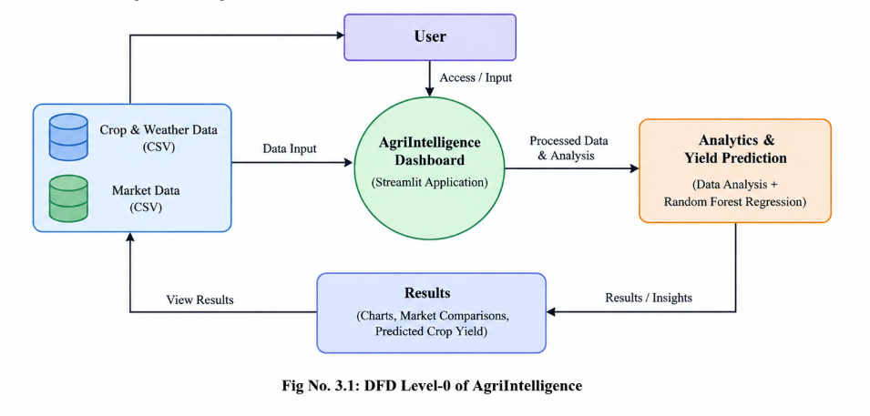

CHAPTER 4
Implementation and User Interface

4.1 Web Page Details
The AgriIntelligence application consists of the following main pages/modules:
- Home Page / Dashboard
- Crop Analytics
- Weather Analytics
- Agricultural Factors
- Market Analytics
- Crop Yield Prediction
4.2 Detailed Description of Pages
1. Home Page / Dashboard
The home page provides access to the AgriIntelligence application and its agricultural analytics features. Users can navigate through the different modules to explore crop yield information, weather-related factors, agricultural data, market prices, and crop yield predictions. The dashboard provides an interactive interface for analyzing agricultural information.
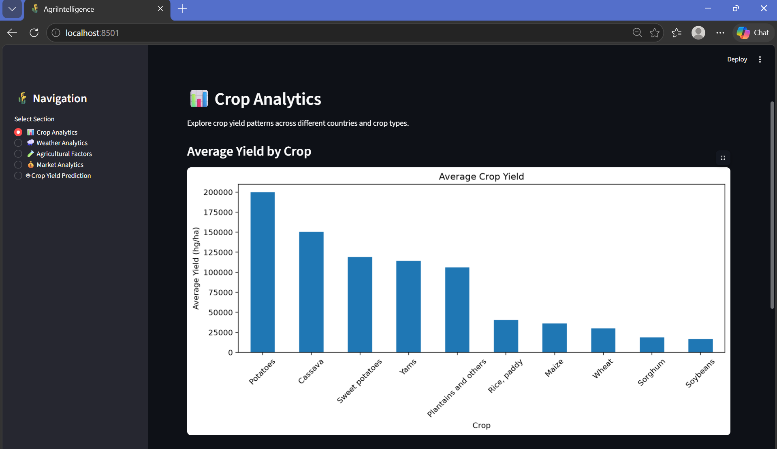
Fig No. 4.1: Home Page / Dashboard
2. Crop Analytics Page
The Crop Analytics page presents information about crop productivity using the available crop dataset. It displays the average yield of different crops and highlights countries with high average crop yields. The visualizations help users compare crop performance and understand productivity patterns in the dataset.
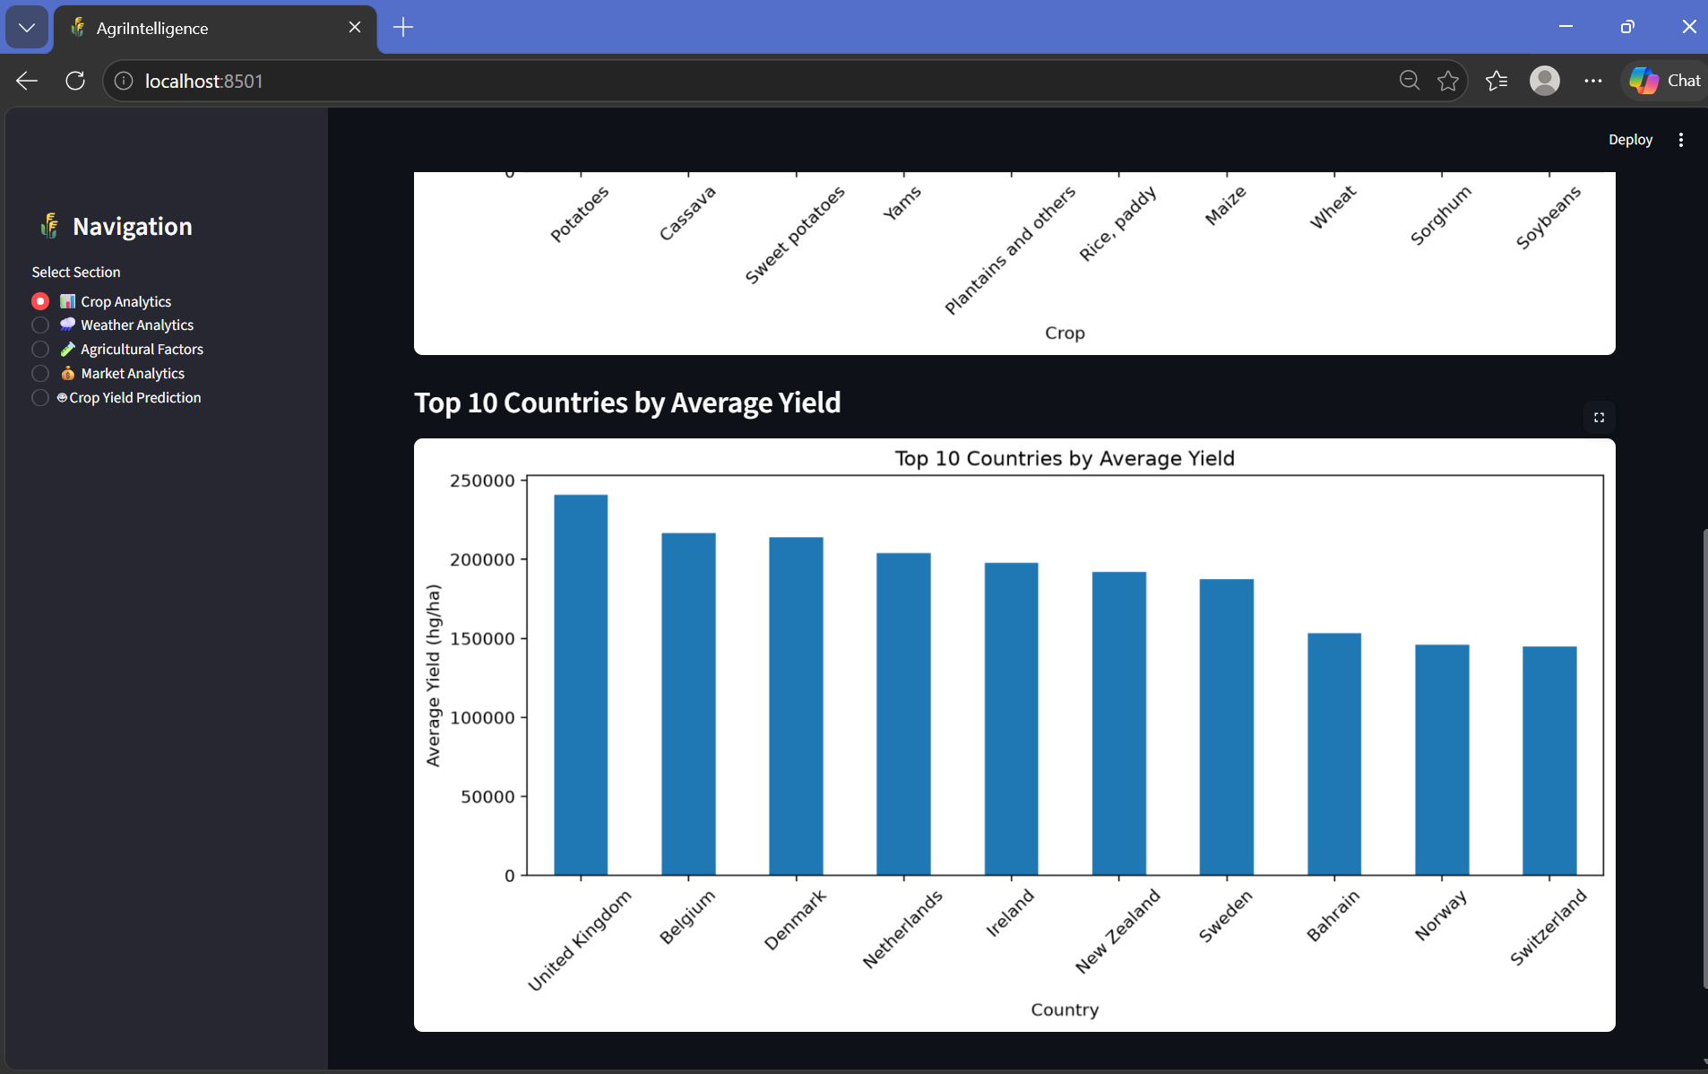
Fig No. 4.2: Crop Analytics Page
3. Weather Analytics Page
The Weather Analytics page explores the relationship between weather-related factors and crop yield. It analyzes rainfall and temperature values and presents yield patterns using graphical visualizations. This page helps users understand how variations in weather conditions are associated with crop productivity in the available dataset.
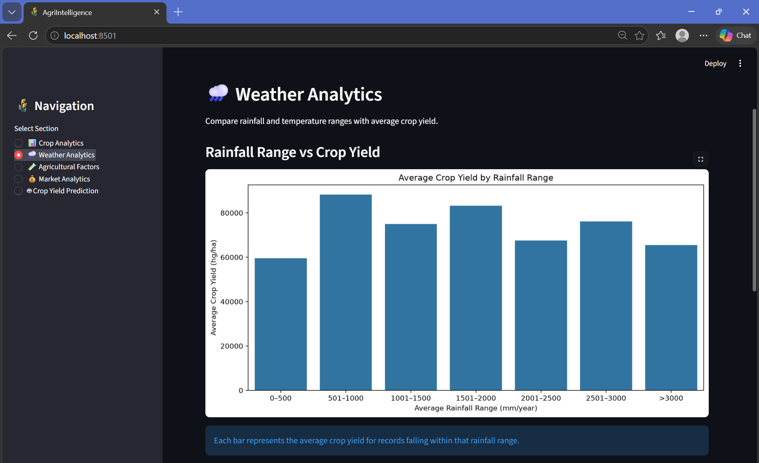
Fig No. 4.3: Weather Analytics Page
4. Agricultural Factors Page
The Agricultural Factors page focuses on agricultural variables such as pesticide usage and their relationship with crop yield. It includes visualizations that help users examine pesticide usage patterns and correlations among selected variables. The analysis provides insights into the relationships between agricultural factors and productivity.

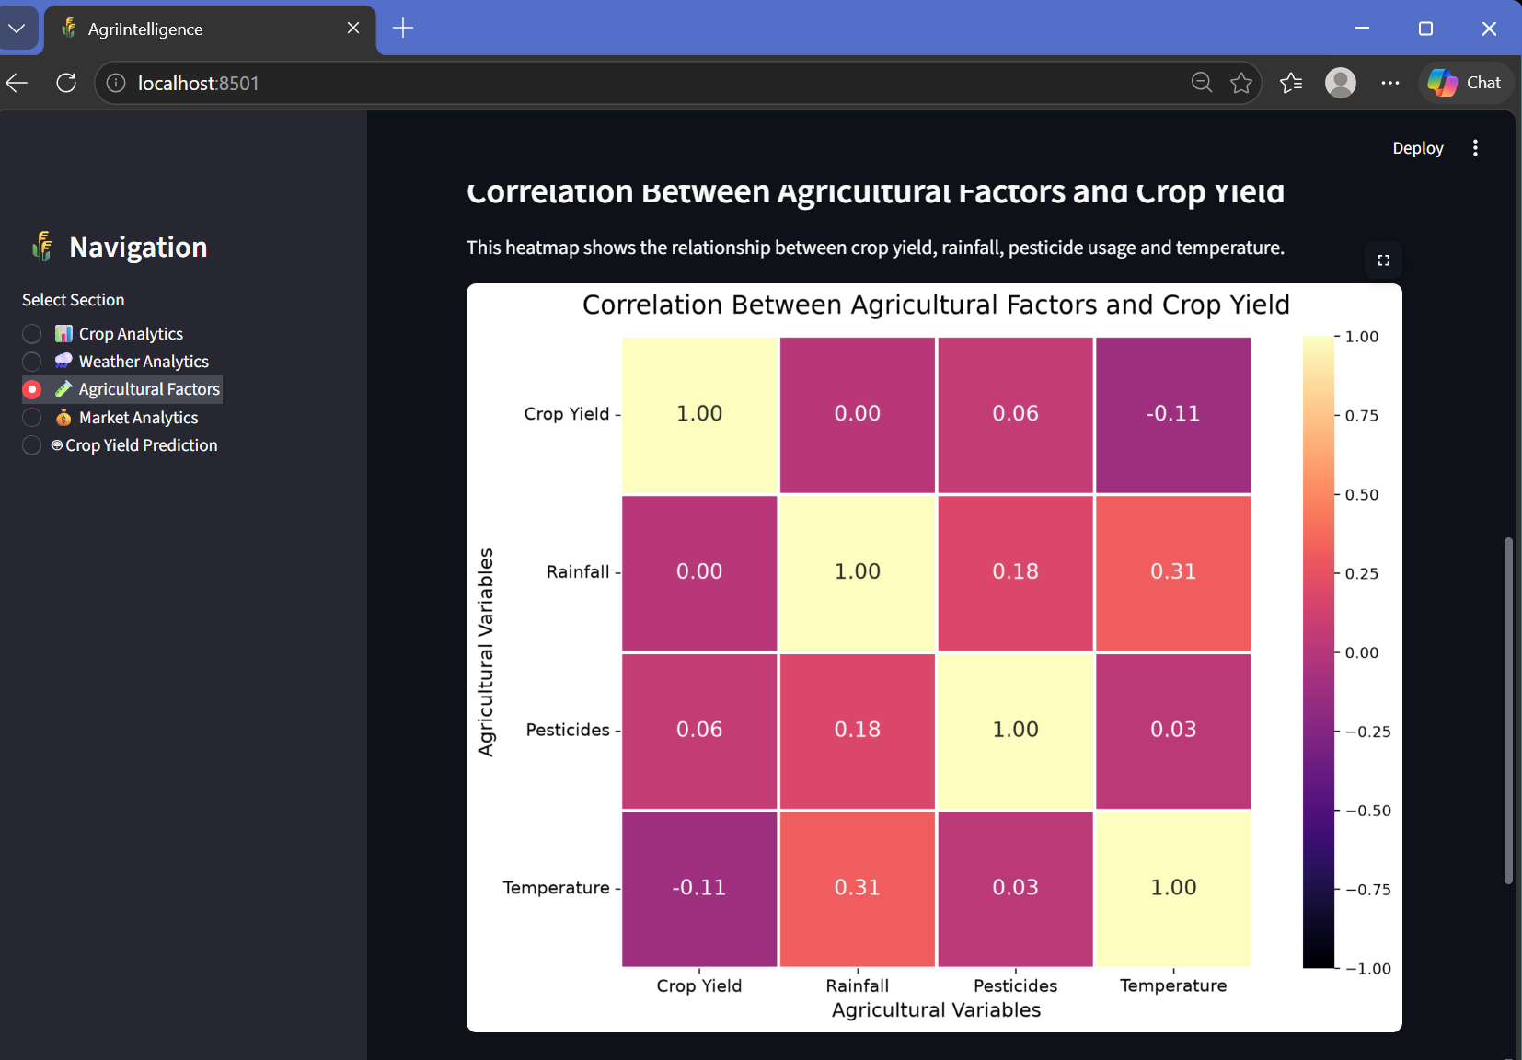
Fig No. 4.4: Agricultural Factors Page
5. Market Analytics Page
The Market Analytics page provides information about agricultural commodity prices using the available market dataset. Users can select commodities, examine price information, view market price trends, and compare market records. Charts and tables help users understand variations in commodity prices across the available data.
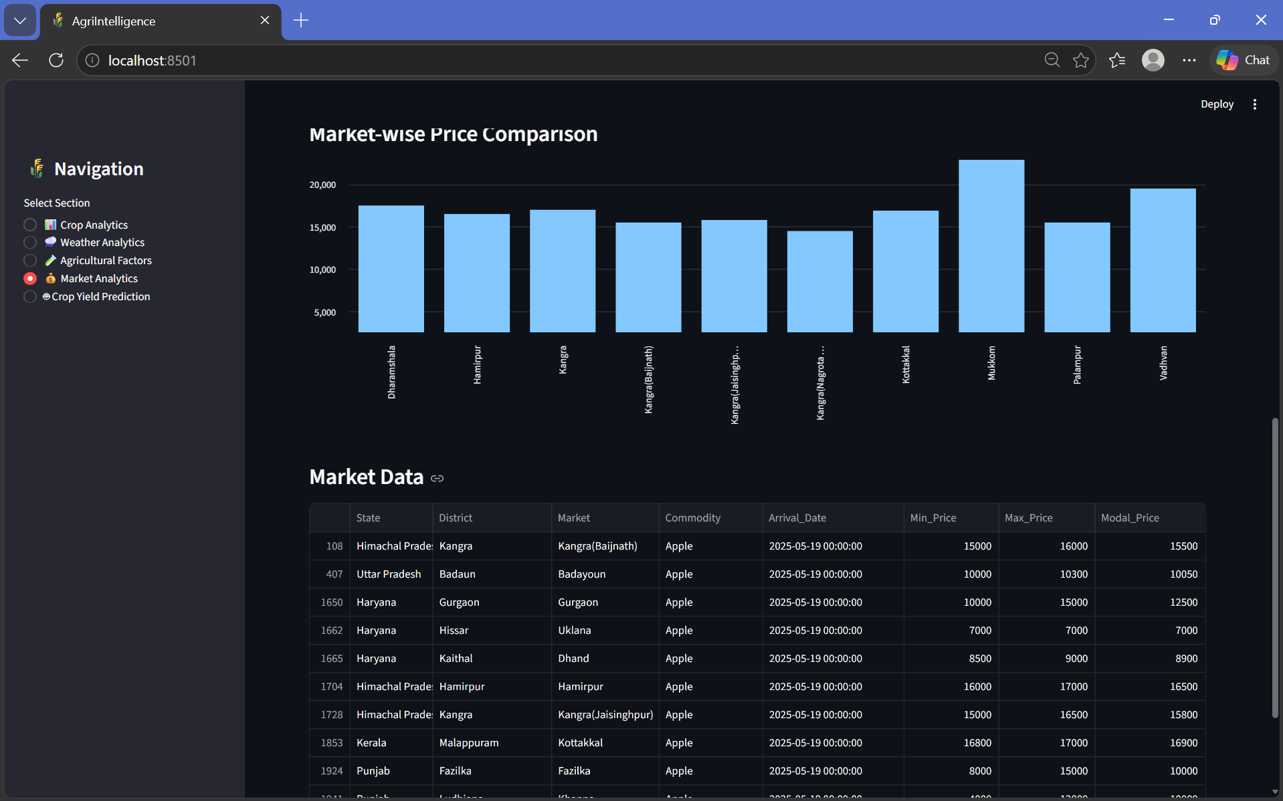
Fig No. 4.5: Market Analytics Page
6. Crop Yield Prediction Page
The Crop Yield Prediction page allows users to estimate crop yield by entering relevant parameters, including country, crop type, year, rainfall, pesticide usage, and temperature. The application uses a trained Random Forest Regression model to generate the predicted yield. This module demonstrates the use of machine learning to analyze agricultural data and support data-driven decision-making.
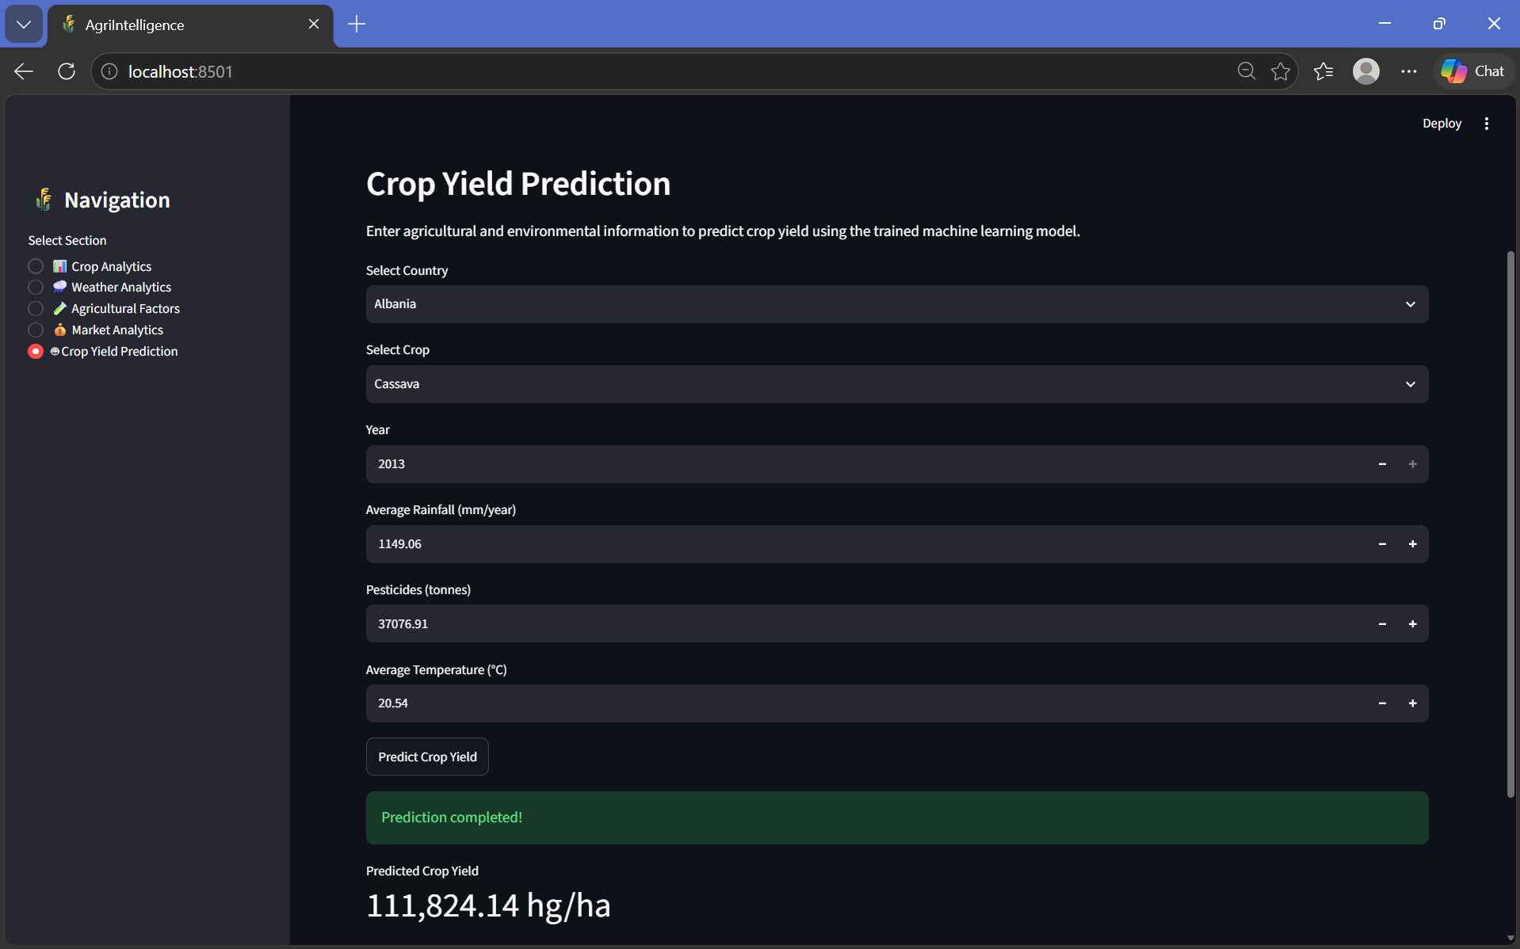
Fig No. 4.6: Crop Yield Prediction Page

CHAPTER 5

Conclusion and Future Aspects

5.1 Conclusion
We have developed “AgriIntelligence – An End-to-End Crop, Weather & Market Analytics Platform” to help users understand agricultural data more effectively. The platform integrates crop, weather, crop yield, and agricultural market price information in one place. Using Python libraries such as Pandas, NumPy, Matplotlib, Seaborn, and Scikit-learn, we perform data preprocessing, exploratory data analysis, and crop yield prediction using a Random Forest Regression model.
The interactive dashboard developed using Streamlit helps users explore agricultural information through visualizations and analytical results. The platform aims to make agricultural data easier to understand and support better decision-making for farmers and other agricultural stakeholders. Overall, AgriIntelligence provides an integrated approach to agricultural data analysis and demonstrates how data science and machine learning can be applied to agricultural problems.

5.2 Future Aspects
- Weather Forecast Integration: We can integrate real-time weather APIs to provide updated information about rainfall, temperature, and other weather conditions.
- Crop Recommendation System: We can develop a feature that recommends suitable crops based on soil conditions, rainfall, temperature, and other agricultural factors.
- Improved Yield Prediction: We can train and evaluate additional machine learning models using more diverse datasets to improve prediction accuracy.
- Market Price Forecasting: We can add a feature to predict future agricultural commodity prices using historical market data and machine learning techniques.
- Farmer-Friendly Interface: We can improve the dashboard with regional language support and a simpler interface so that more farmers can use it easily.
- Mobile Application: We can develop a mobile application to make agricultural insights accessible to users from different locations.
- Alerts and Notifications: We can introduce SMS or mobile notifications to inform users about important weather changes, market price updates, and other agricultural information.

CHAPTER 6
Bibliography

1 . Python Software Foundation. “Python Documentation.” https://docs.python.org/3/

Pandas Development Team. “Pandas Documentation.” https://pandas.pydata.org/docs/

NumPy Developers. “NumPy Documentation.” https://numpy.org/doc/

Matplotlib Development Team. “Matplotlib Documentation.” https://matplotlib.org/stable/

Seaborn Developers. “Seaborn Documentation.” https://seaborn.pydata.org/

Scikit-learn Developers. “Scikit-learn Documentation.” https://scikit-learn.org/stable/

Streamlit. “Streamlit Documentation.” https://docs.streamlit.io/

Klompenburg, T. V., et al. “Crop Yield Prediction Using Machine Learning: A Systematic Literature Review.”

Elavarasan, D., et al. “Forecasting Yield by Integrating Agrarian Factors and Machine Learning Models.”

Prasad, K. R., et al. “Weather-Based Statistical and Neural Network Tools for Forecasting Rice Yields in Major Growing Districts of Karnataka.”

CHAPTER 7

Appendices

7.1 Libraries Used in the Project
The AgriIntelligence project uses Python libraries for data processing, visualization, machine learning, and deployment. The following code is present in the project's Jupyter Notebook.
import pandas as pd
import numpy as np
import matplotlib.pyplot as plt
import seaborn as sns
The project also uses Scikit-learn for model training and evaluation, Joblib for saving the trained model, and Streamlit for the interactive dashboard.
7.2 Loading the Crop Yield Dataset
The crop dataset is loaded from the project's data folder using Pandas.
df = pd.read_csv("../data/crop_data.csv")
df.shape
df.columns
df.head()
df.info()
df.isnull().sum()
df.duplicated().sum()
These commands are used to inspect the dataset's dimensions, column names, sample records, data types, missing values, and duplicate records.
7.3 Data Cleaning and Preprocessing
The notebook removes an unnecessary index column and renames the original dataset columns into more meaningful names.
df = df.drop(columns=["Unnamed: 0"])
df = df.rename(columns={
"Area": "Country",
"Item": "Crop",
"hg/ha_yield": "Yield",
"average_rain_fall_mm_per_year": "Rainfall",
"pesticides_tonnes": "Pesticides",
"avg_temp": "Temperature"
})

df.head()
df.info()
df.describe()
The renamed columns make the dataset easier to understand and use for analysis and crop yield prediction.
7.4 Exploratory Data Analysis
The project analyzes crop distribution and average crop yield using bar charts.
crop_counts = df["Crop"].value_counts()
plt.figure(figsize=(10, 6))
crop_counts.plot(kind="bar")
plt.title("Number of Records by Crop")
plt.xlabel("Crop")
plt.ylabel("Number of Records")
plt.xticks(rotation=45)
plt.tight_layout()
plt.show()
The average yield for each crop is calculated as follows:
avg_yield_crop = (
df.groupby("Crop")["Yield"]
.mean()
.sort_values(ascending=False)
)

plt.figure(figsize=(10, 6))
avg_yield_crop.plot(kind="bar")
plt.title("Average Crop Yield")
plt.xlabel("Crop")
plt.ylabel("Average Yield (hg/ha)")
plt.xticks(rotation=45)
plt.tight_layout()
plt.show()
The notebook also studies the relationship between rainfall, temperature, pesticide usage, and crop yield using scatter plots and a correlation heatmap.
numeric_cols = [
"Year", "Yield", "Rainfall",
"Pesticides", "Temperature"
]

plt.figure(figsize=(8, 6))
sns.heatmap(
df[numeric_cols].corr(),
annot=True,
cmap="coolwarm",
fmt=".2f"
)
plt.title("Correlation Between Agricultural Variables")
plt.tight_layout()
plt.show()
7.5 Crop Yield Prediction Model
The project uses Linear Regression and Random Forest Regression for model development and comparison. The input features are country, crop, year, rainfall, pesticide usage, and temperature.
from sklearn.model_selection import train_test_split
from sklearn.preprocessing import OneHotEncoder
from sklearn.compose import ColumnTransformer
from sklearn.pipeline import Pipeline
from sklearn.linear_model import LinearRegression
from sklearn.ensemble import RandomForestRegressor
X = df[
[
"Country", "Crop", "Year",
"Rainfall", "Pesticides", "Temperature"
]
]
y = df["Yield"]
X_train, X_test, y_train, y_test = train_test_split(
X, y,
test_size=0.2,
random_state=42
)
Categorical columns are encoded using One-Hot Encoding, while the remaining numerical columns are passed through the preprocessing stage.
categorical_features = ["Country", "Crop"]
preprocessor = ColumnTransformer(
transformers=[
(
"cat",
OneHotEncoder(handle_unknown="ignore"),
categorical_features
)
],
remainder="passthrough"
)
rf_model = Pipeline([
("preprocessor", preprocessor),
("model", RandomForestRegressor(
n_estimators=100,
random_state=42,
n_jobs=-1
))
])
rf_model.fit(X_train, y_train)
rf_pred = rf_model.predict(X_test)
The trained Random Forest model is saved for later use in the Streamlit application.
import joblib
joblib.dump(
rf_model,
"../src/crop_yield_model.pkl"
)
7.6 Model Evaluation
The project evaluates the model using Mean Absolute Error (MAE), Mean Squared Error (MSE), Root Mean Squared Error (RMSE), and the R² score.
from sklearn.metrics import (
mean_absolute_error,
mean_squared_error,
r2_score
)
import numpy as np
y_pred = rf_model.predict(X_test)
mae = mean_absolute_error(y_test, y_pred)
mse = mean_squared_error(y_test, y_pred)
rmse = np.sqrt(mse)
r2 = r2_score(y_test, y_pred)
print("Model Performance")
print("------------------")
print("MAE :", mae)
print("MSE :", mse)
print("RMSE:", rmse)
print("R2 Score:", r2)
The saved results/model_metrics.txt file contains the following recorded results:
Evaluation Metric | Recorded Value
MAE | 3466.6454
MSE | 89633723.9258
RMSE | 9467.5089
R² Score | 0.987643
The recorded R² score is approximately 98.76%. This indicates a strong fit on the evaluated test dataset; it does not guarantee the same accuracy on all future data.
7.7 Actual Versus Predicted Yield and Feature Importance
The notebook generates a scatter plot to compare actual crop yield values with the model's predicted values.
plt.figure(figsize=(8, 5))
plt.scatter(y_test, y_pred, alpha=0.5)
plt.xlabel("Actual Yield")
plt.ylabel("Predicted Yield")
plt.title("Actual vs Predicted Crop Yield")
plt.tight_layout()
plt.savefig(
"../results/actual_vs_predicted.png",
dpi=300,
bbox_inches="tight"
)
plt.show()
The notebook also calculates feature importance for the trained Random Forest model and saves the visualization in the results folder.
model = rf_model.named_steps["model"]
preprocessor = rf_model.named_steps["preprocessor"]
features = preprocessor.get_feature_names_out()

importance = model.feature_importances_
plt.figure(figsize=(10, 8))
plt.barh(features, importance)
plt.xlabel("Importance")
plt.ylabel("Features")
plt.title("Feature Importance for Crop Yield Prediction")
plt.tight_layout()
plt.savefig(
"../results/feature_importance.png",
dpi=300,
bbox_inches="tight"
)
plt.show()
7.8 Agricultural Market Data Processing
The project loads the agricultural market dataset and standardizes the price column names.
market_df = pd.read_csv("../data/market_data.csv")
market_df.rename(columns={
"Min_x0020_Price": "Min_Price",
"Max_x0020_Price": "Max_Price",
"Modal_x0020_Price": "Modal_Price"
}, inplace=True)
market_df["Arrival_Date"] = pd.to_datetime(
market_df["Arrival_Date"],
dayfirst=True
)
price_cols = [
"Min_Price", "Max_Price", "Modal_Price"
]
for col in price_cols:
market_df[col] = pd.to_numeric(
market_df[col],
errors="coerce"
)
market_df.dropna(
subset=[
"Commodity", "Market",
"Arrival_Date", "Modal_Price"
],
inplace=True
)
market_df.to_csv(
"../data/cleaned_market_data.csv",
index=False
)
This processing standardizes price fields, converts dates and prices into suitable data types, removes records missing important values, and saves the cleaned dataset.
7.9 Agricultural Market Analysis and Visualization
The notebook calculates average modal prices by commodity and identifies the ten commodities with the highest average prices.
commodity_prices = market_df.groupby(
"Commodity"
)["Modal_Price"].mean().sort_values(ascending=False
top_commodities = commodity_prices.head(10)

plt.figure(figsize=(10, 6))

plt.barh(
top_commodities.index[::-1],
top_commodities.values[::-1]
)
plt.xlabel("Average Modal Price")
plt.ylabel("Commodity")
plt.title("Top 10 Commodities by Average Market Price")
plt.tight_layout()
plt.savefig(
"../results/top_commodities_market_price.png",
dpi=300,
bbox_inches="tight"
)
plt.show()
The notebook also creates market-wise price comparisons and a market price trend over time. The resulting figures are saved as market_price_comparison.png and market_price_trend.png in the results folder.

7.10 Streamlit Application
The main application is implemented in app.py. It loads the cleaned crop dataset, cleaned market dataset, and trained Random Forest model.
import streamlit as st
import pandas as pd
import joblib
import matplotlib.pyplot as plt
import seaborn as sns

st.set_page_config(
page_title="AgriIntelligence",
page_icon="🌾",
layout="wide"
)

df = pd.read_csv("data/cleaned_crop_data.csv")
market_df = pd.read_csv("data/cleaned_market_data.csv")

market_df["Arrival_Date"] = pd.to_datetime(
market_df["Arrival_Date"],
errors="coerce"
)
model = joblib.load("src/crop_yield_model.pkl")
st.title("🌾 AgriIntelligence")
st.subheader(
"End-to-End Crop, Weather & Market Analytics Platform"
)
The sidebar provides navigation to five sections: Crop Analytics, Weather Analytics, Agricultural Factors, Market Analytics, and Crop Yield Prediction.
The prediction section accepts country, crop, year, rainfall, pesticide usage, and temperature as inputs. When the user clicks the prediction button, the trained model generates an estimated crop yield.
7.11 Project Execution
The project folder contains the following important files:
- app.py – Main Streamlit application.
- app_backup.py – Backup version of the application.
- data/crop_data.csv – Original crop dataset.
- data/cleaned_crop_data.csv – Cleaned crop dataset.
- data/market_data.csv – Original market dataset.
- data/cleaned_market_data.csv – Cleaned market dataset.
- notebooks/ArgiIntelligence.ipynb – Data analysis, model training, and market analysis notebook.
- src/crop_yield_model.pkl – Saved trained model.
- results/ – Generated charts and model evaluation metrics.
- requirements.txt – Dependency file included in the project.
From the project root directory, the application can be started using:
python -m pip install pandas numpy matplotlib seaborn scikit-learn joblib streamlit
python -m streamlit run app.py

7.12 Summary
The execution folder demonstrates the implementation of data loading, crop dataset preprocessing, exploratory data analysis, comparison of regression models, Random Forest training, model evaluation, market price analysis, chart generation, and an interactive Streamlit dashboard. These components form the core implementation of the AgriIntelligence project.

